Reflexive Verbs
llamarse to be named
me llamo | nos llamamos
te llamas
se llama | se llaman
A reflexive verb is a verb that is accompanied by a reflexive pronoun. This verb construction is used when a person performs an action to or for him/herself. In other words, the subject of the verb and the direct object of the verb are the same person. It is important to note that reflexive verbs can sometimes be unintuitive for English speakers because they are not very common in English yet they are used quite a bit Spanish. So it is important to learn not just how to form reflexive verbs but also when to use them.
You have probably already seen the reflexive verb llamarse when you learned to introduce yourself in Spanish, as seen in the first example below. Another typical use of reflexive verbs is personal care and emotions, as seen in examples two and three.
Yo me llamo Dora y nací en McAllen, Texas.My name is Dora and I was born in McAllen, Texas.
https://www.coerll.utexas.edu/spintx/player/461/?start=1&end=6
En la mañana te levantabas y te levantabas a bañarte al río.In the morning you got up and you got up to bathe (yourself) in the river .
https://www.coerll.utexas.edu/spintx/player/1574/?start=150&end=155

Cuando nos reunimos, es como que si estuviéramos en El Salvador. Todos nos ponemosfelices, la bulla que hacemos, la cultura nunca se deja.When we get together, it’s like we are in El Salvador. We all get so happy, the ruckus that we make, you never let go of your culture.
https://www.coerll.utexas.edu/spintx/player/442/?start=44&end=54

Formation
To conjugate reflexive verbs, the verb is conjugated according to the subject and the reflexive pronoun matches subject in person (1st, 2nd, or 3rd) and in number (singular or plural). In the example, levantabas is conjugated in the second person singular and te is also second person singular. Also note that reflexive verbs can appear as infinitive as well such as bañarte because the conjugated verb levantabas acts as an auxiliary verb.
En la mañana te levantabas y te levantabas a bañarte al río.In the morning you got up and you got up to bathe (yourself) in the river.
https://www.coerll.utexas.edu/spintx/player/1574/?start=150&end=155

Pronoun Placement
There are two places where reflexive pronouns can be placed, as seen in the example above.
- Before a conjugated verb
- Attached to the end of the verb, ONLY IF the verb is not conjugated, such as infinitives or gerunds or if the verb is an affirmative informal command.
Uses
Reflexive Actions and Emotions
Reflexive verbs often express reflexive actions, that is, the subject performs the action on itself, like bañarse, to bathe, despertarse, to wake up, sentarse, to sit down or an emotional response to something, like enojarse, to get angry, alegrarse, to get happy, aburrirse, to become bored, enamorarse, to fall in love, calmarse, to calm down,preocuparse, to worry. These verbs can be used as 1) reflexive verbs or 2) non-reflexive verbs if the action is being done to someone other than the subject. Notice how in the first example, the verb preocupar is used reflexively, meaning someone worries about something. Whereas in the second example the verb preocupar is not reflexive, meaning that something worries someone. In this example, the direct object me is and the subject eso.
Nos preocupamos por lo que les pasa. Nos preocupamos por qué les falta, por la salud de ellos, por el bienestar.We worry about what happens to them.
We worry about what they’re missing, about their health, about their well-being.
https://www.coerll.utexas.edu/spintx/player/574/?start=16&end=26
¿Nunca has estado enamorada? — Sí, una vez sí, creo. Pero ahorita eso está abajo de mi lista. Eso no me preocupa.You’ve never been in love? Yes, once I think. But right now that’s on the bottom of my list. It does not worry me.
https://www.coerll.utexas.edu/spintx/player/1352/?start=12&end=29

Meaning Changes
Some verbs, when in the regular or reflexive form, change their meaning as seen in the table below.
Verb | Used Reflexively | Used Non-Reflexively
dormir | to sleep | to fall asleep
ir | to go | to go away, to leave
llamar | to be named | to call
llevar | to carry | to take away
negar | to deny | to refuse
probar | to try, to taste | to try on
Compare the difference in meaning between the reflexive verb llamarse and the regular verb llamar, to call in the examples below:
Yo me llamo Dora y nací en McAllen, Texas.My name is Dora and I was born in McAllen, Texas.
https://www.coerll.utexas.edu/spintx/player/461/?start=1&end=6
Y mi papá llamó al vecino.And my dad called my neighbor.
https://www.coerll.utexas.edu/spintx/player/1576/?start=142&end=147

Reflexives Only
A few verbs can only be reflexive (burlarse, to make fun of, quejarse, to complain, arrepentirse, to regret, atreverse, to dare, equivocarse, to make a mistake, darse cuenta de, to realize, etc.). These often do not even to describe a reflexive action, it is just the grammatical form they take.
No me daba cuenta de los peligros.I was not aware of the dangers.
https://www.coerll.utexas.edu/spintx/player/467/?start=108&end=112
Sí, me arrepiento de algo y lo recuerdo de una manera muy triste.Yes, I regret something and I remember that in a very sad way.
https://www.coerll.utexas.edu/spintx/player/504/?start=37&end=44

To Get
Many times the English translation will use the verb get instead of using a reflexive construction. See in the following examples how the English translation does not uses a reflexive verb where Spanish does.
Me metí a bañarme y pues acabé de bañarme, pero empecé a marearme muy feo y entonces me arrastré hacia la puerta.I got in to take a bath and I finished bathing but I started to get really dizzy and then I dragged myself to the door.
https://www.coerll.utexas.edu/spintx/player/474/?start=58&end=72

With Body Parts
Unlike English, when reflexive verbs are used with parts of the body, they take the definite article (el, la, los, las) rather than a possessive determiner as in English:
Cuando en la primaria me desmayé y me descalabré la cabeza.When I was in elementary school I fainted and hurt my head.
https://www.coerll.utexas.edu/spintx/player/1541/?start=15&end=24

Me lavo las manos con jabón todos los días.I wash my hands with soap every day.
Reflexivity
Another way to explain reflexive verbs is this: If a verb in its infinitive form ends with – se, it is called a reflexive verb. Some verbs are always reflexive, but almost any verb you have already learned can be used as a reflexive verb. The term “reflexive” indicates that the subject of the verb both causes and receives the action of the verb. The verb lavar means to wash (something or someone else), the reflexive verb lavarse means to wash oneself.

Reflexive pronouns
In Spanish, a reflexive verb has an extra pronoun used with or without the subject pronoun that reflects the subject. The reflexive pronoun is placed in the sentence in exactly the same position as a direct or indirect object pronoun. If a reflexive pronoun is used in conjunction with a direct or indirect object pronoun (never with both at the same time), the reflexive pronoun is always first. The order of pronouns in a sentence is easily remembered with the acronym SRID:

- Subject
- Reflexive
- Indirect object
- Direct object

Although all four pronouns are never used together, whatever pronouns appear in a sentence will follow the order SRID. The subject of a sentence may be understood, but if there is a subject pronoun, it will precede all other pronouns. In the following examples, the reflexive pronouns are in bold, indirect pronouns are underlined, and direct objects are both underlined and in bold.

The sentence may have a reflexive and indirect object pronoun:
Se me acaba la disputa. (The argument is over for me.)

The sentence may have a reflexive and direct object pronoun:
Yo Me lavo la cara antes de dormir. Me la lavo cada noche.

The sentence may have an indirect and direct object pronoun:
Es necesario comprar mucha medicina. Mis padres me la compran cuando estoy enfermo.

Notice in all of these examples that the order of the pronouns is consistent. Regardless of how many pronouns are used, they will always be in the SRID order: subject, reflexive, indirect object, and then direct object—all before the conjugated verb form.

When a reflexive verb is conjugated in any tense, the – se is removed from the infinitive form, and the appropriate reflexive pronoun is used to reflect the subject of the sentence. Notice in Table 1 that the reflexive pronouns are similar to direct and indirect object pronouns but are even easier to learn because the third person form of the reflexive pronoun is always se. The reflexive pronouns are listed with the subject pronouns that they reflect. Sometimes the subject pronoun is not used, but if a verb is being used reflexively, the reflexive pronoun is required.

Table 1 indicates subject pronouns and their corresponding reflexive pronouns.
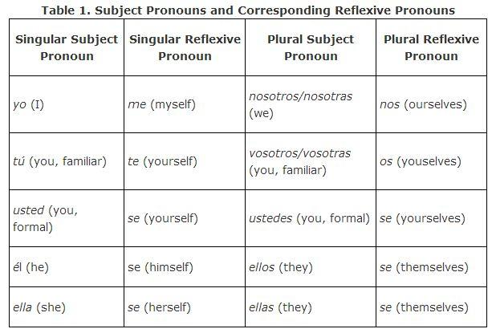
Table 2 demonstrates how to conjugate a reflexive verb in the present tense.
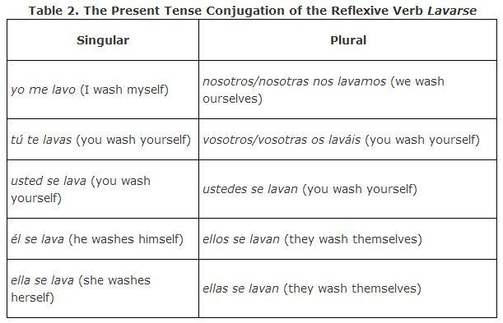

Reciprocity
When plural subjects have reflexive pronouns, there are actually two possible interpretations. Reflexive pronouns can indicate that the action of the verb falls back on the subject, or reciprocity. That means the people represented by the plural subject do the action of the verb to each other. Sometimes it is obvious that the reflexive pronoun is being used to indicate reciprocity. For example:

Ellos se casaron el 21 de mayo.
They married (each other) on May 21st.

Technically, the sentence could be stating that they married themselves, but logic allows us to assume that reciprocity is indicated. The other use of the reflexive can be assumed in a sentence, such as:

Nosotros nos bañamos cada mañana.
We bathe ourselves each morning.

It is possible, but not probable, that we bathe each other. When a reflexive verb has a plural subject, there will be two possible translations, but the context of the sentence should give away the correct interpretation. This problem does not occur when the subject is singular because it is impossible to have reciprocity with only one person.

Reflexive verbs
The section on reflexive verbs is included here because reflexive pronouns are used if the verb of the sentence being conjugated is a reflexive verb. It is difficult to understand when to use a reflexive pronoun unless you understand the most common verbs that are always reflexive and how a verb that is not normally reflexive can be used in a “reflexive way” that requires a reflexive pronoun. A verb that is reflexive is not irregular. It has the same conjugation as a non‐reflexive verb except that an extra pronoun is used with it.

The closest equivalent in English would be using myself, yourself, himself, herself, ourselves, or themselves after the verb. Another use of the reflexive is to indicate that the members of a plural subject do something to each other.

Many reflexive verbs refer to doing something to one's own body. Because the reflexive pronoun already indicates that the subject of the sentence is doing the action of the verb to him/herself, it is considered repetitive to use a possessive adjective in front of the body parts in question. The appropriate definite article is used in front of the body part instead of a possessive adjective.

Yo me peino ( el pelo) dos veces al día.
I comb my hair twice a day.

Lupe se lava las manos antes de comer.
Lupe washes her hands before eating.

Verbs like caer or dormir are used reflexively to indicate that the action of the verb happened without the subject of the verb's voluntary cooperation.

El estudiante, aburrido, se durmió durante la lección.
The bored student fell asleep during the lesson.

Yo me caí enfrente de la clase.
I fell down in front of the class.

Common reflexive verbs
Many of the verbs below are always reflexive, and some of the verbs you have seen before without the –se. When these verbs are indicating that the subject is doing the action of the verb to itself, they become reflexive verbs and require the reflexive pronoun.

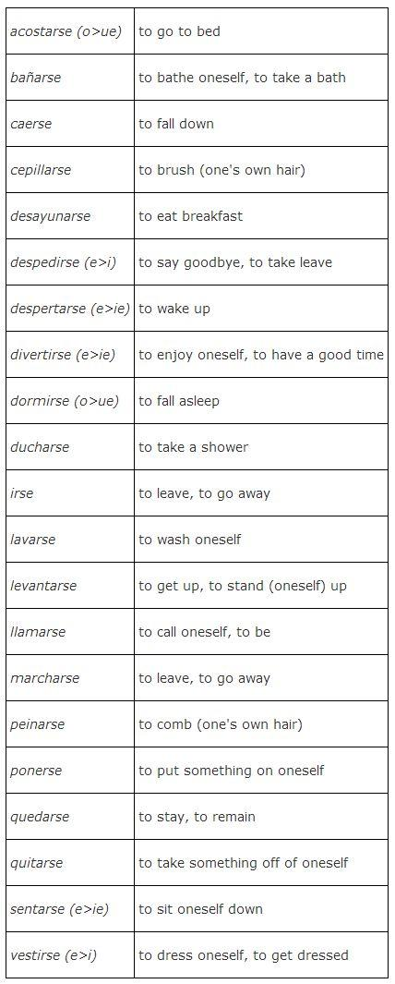

JESSICA: PRACTICE ACTIVITIES FOLLOW correct answers are highlighted in yellow

Choose the appropriate reflexive pronoun to complete the sentence.

1. Los niños _____ acuestan a las diez de la noche.
- se
- te
- me
2. ¿(You all, familiar) duchan por la mañana o por la noche?
- Nos
- Te
- Os

3. Mi esposo y yo _____ acostamos temprano.
Se
Nos
Me

- En la fiesta de año nuevo yo ____ divertí mucho.
Me
Te
Nos

- Los profesores _____ fueron después de trabajar.
Se
Me
Te

6___lavo la cara antes de cepillarme los dientes.
Te
Me
Se
- _____ dormí a la medianoche y _____ desperté a las seis de la mañana.
Me, me
Me, te
Me, nos

JESSICA: IN THE FOLLOWING ACTIVITY THE CORRECT ANSWER ARE NOTED IN THE DROP DOWN BOXES. students can use a capital letter for first word or not:
me despierto / Me despierto.

Conjugate the following reflexive verbs using the subjects provided. Remember that each blank should have a reflexive pronoun as well as the conjugation of the verb.
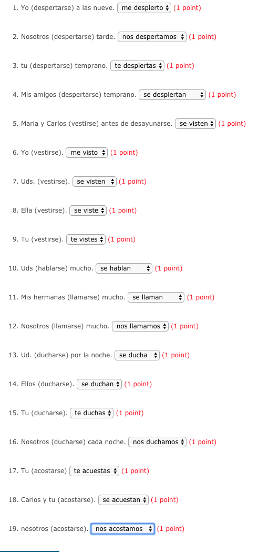
JESSICA: CORRECT ANSWERS IN BOLD IN FOLLOWING ACTIVITY

For each of the following reflexive verbs, provide the correct pronoun and conjugation in the present tense. Follow the model.

MODELO: Tú (ducharse). te duchas.

Mis hermanos (sentarse) en el sofá.
se sientan

Yo (afeitarse) las piernas. me afeito

¿Tú siempre (lavarse) las manos? te lavas

Las niñas (vestirse) con vestidos color amarillo. se visten

Mi padre (ducharse) temprano por la mañana. se ducha

Gabriela (mirarse) en el espejo. se mira

Juan (acostarse) a las diez de la noche. se acuesta

Nosotros (sentarse) en el comedor. nos sentamos

Nosotros (cepillarse) los dientes. nos cepillamos

(Ella ducharse) a las ocho de la mañana. se ducha

Tú (peinarse) el pelo. te peinas
Ella (vestirse) con un traje. se viste

Ellos (ducharse) cada mañana. se duchan

Tu (lavarse) la cara. te lavas

María (peinarse) el pelo. me peino

Yo (bañarse). me baño

Ustedes (despertarse) a las seis. me despierto

Nosotros (irse) del edificio a las cinco. nos vamos

Yo (despertarse) a las seis de la mañana. me despierto

Nostros (dormirse) a las nueve de la noche. nos dormimos

Mi padre (afeitarse) por la mañana. se afeita

María (lavarse) el pelo. se lava

(Yo peinarse) después de ducharme. me peino

Anita (quitarse) los zapatos. se quita

JESSICA: FOR THE FOLLOWING ACTIVITY CORRECT ANSWERS ARE IN CAPS AFTER THE PERIOD IN EACH SENTENCE THEY SHOULD BE LOWERCASE, LIKE THIS: se afeita

1. Mi hermano (afeitarse) todas las mañanas. SE AFEITA
2. Mis primos (levantarse) temprano. SE LEVANTAN
3. (lavarse,yo) la cabeza con champú para niños. ME LAVO
4. ¿ (ducharse,tú) todos los días? TE DUCHAS
5. (acostarse,nosotros) antes de las diez. NO ACOSTAMOS
6. (lavarse,vosotros) las manos antes de comer. OS LAVÁIS
7. (llamarse,yo) Sara, pero mis amigos me llaman Sarita. ME LLAMO
8. En verano (bañarse,yo) en el mar. ME BAÑO
9. Mi padre (sentarse) siempre en el mismo sillón. SE SIENTA
10. Por la mañana (vestirse,yo) antes de desayunar. ME VISTO

JESSICA: THIS WILL BE A SUBMISSION; can the first one be a MODELO? If not, that’s OK. If so, it is this and the MODELO sentence can go above the picture of the guy showering.
MODELO: Yo me ducho todas las noches.

Ejercicio : Para Practicar Reflexivos
Instrucciones: Completa cada oración con un verbo reflexivo apropiado. ¡No te olvides de escribir el pronombre reflexivo y la forma del verbo apropiados!

 |  | 
Yo ___ ________ todas las noches. | ¿Con qué frecuencia tú ___ ________? | Ester ___ ________ en el espejo.
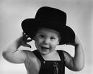 |  | 
Nosotros ___ ________ un sombrero porque hace fresco hoy. | Yo ___ ________ antes de vestirme. | ¿A qué hora tú ___ ________?
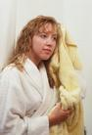 | 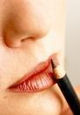 | 
La chica ___ ________ con una toalla. | María ___ ________ porque tiene una cita (date). | Pedro ___ ________ en la silla.
 | 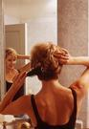 | 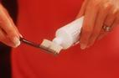
Eduardo ___ ________ una corbata de seda. | Gabriela ___ ________. | ¿Uds. ___ ________ con Colgate o con Crest?

JESSICA: THIS WILL BE A SUBMISSION

WRITE 8-10 SENTENCES DESCRIBING YOUR DAILY ROUTINE. USE AT LEAST 6 REFLEXIVE VERBS.

